SQL ASSIGNMENT 10

1)

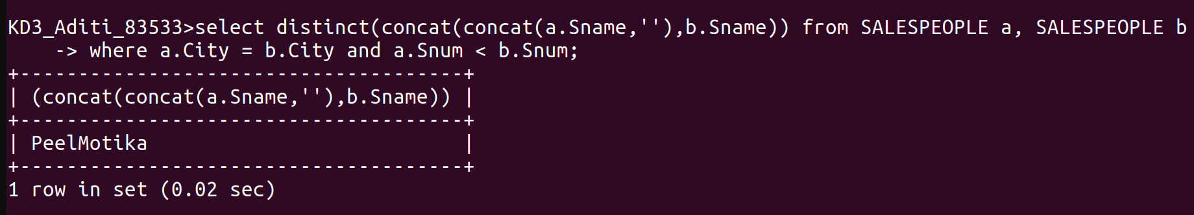

2)

